According to this source: http://www.bostonroads.com/crossings/pell-newport/

"For the Newport span, Bethlehem Steel developed a new construction method that used prefabricated parallel wire strands. The two main cables, each of which measured just over 15 inches in diameter, were coated with a glass fiber-plastic protective casing. Each of the bridge's main cables had 76 strands, and each strand had 61 wires (each 0.2 inch in diameter and measuring 4,516 feet long). Laid end to end, the wires would stretch for more than 8,000 miles. The cables weighed a total of 2,280 tons. This work continued from late 1967 through mid-1968."

So there is 4636 steel wires total. I doubt we could make a full scale model of that. We could do a few different experiments with this. One would be to test acoustic properties against one "strand" of wire, or a bundle of 61 0.2in diam steel wires? Another is to split these individual cablesinto bundles of ten, and test 6 bundles, including snapping of a bundle to see what acoustic emissions can be monitored.

Length and number of cables is dependent on cost of steel cable. Here is a source for wire costs

http://www.mcmaster.com/#metal-wire/=u0x1u3

We are looking at ~$40-50 for 10lbs of cables?

Things to consider: can we use a different wire gauge? How should we make the bundles? How long should the bundles be?

Next we need to consider what tests we will do.

**Passive system**, system design noted in picture

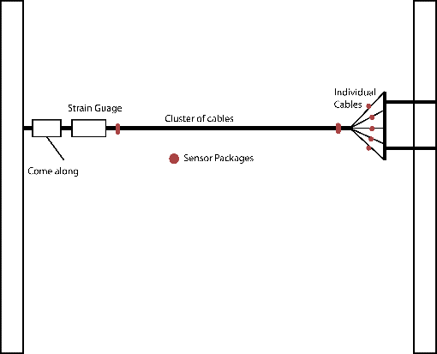

Tension will be applied to the cable bundle, via the come along, until a desired tension is reached via the strain gauge read out. Sensors will be placed at either end and on individual cable strands. They will *only listen* for acoustic events. In order to create an acoustic event there are two options (both of which can be done).

One is using a schmidt hammer. This device measures elastic propertied of a sample by imparting known energy value into the sample. This energy will produce an acoustic event that can be measured. By measuring the time delays at each sensor, the ability to localize the event will be tested. This was chosen as it was used in a similar experiment to model the impulse signal and frequency spectrum of acoustic events in suspension cables.

The other method, is to physically cut the wire. When the wire is cut, the release of energy will create a measurable acoustic event. By measuring the delay and intensities of the acoustic wave as it reaches the individual sensors, it is postulated that both location and individual strand member can be identified. The localization method will be similar to the test with the Schmidt hammer. We assume that the intensity of the acoustic wave in the snapped wire will be measurably greater than the readings found on the sensors attached to the remaining bundles. In this way, the sensor that reads the largest intensity, will be the snapped strand. Spreading of the acoustic energy to the other strands could make this measurement inaccurate. Through testing, this hypothesis can be determined.

**Active experiment**

This test will employ the same design as the previous test. However, the sensor packages attached to the individual strands will not just listen, but also act as projectors. They will send an ultrasonic wave down one of the cables. The resulting wave prorogation will be monitored at the differing sensors located at the end and beginning of the bundle. A strand will then be cut. Again, an acoustic wave will be sent down individually at each strand, and the wave will be monitored at each sensor. What is postulated is that the cut wire will send a reflected acoustic signal that can be measured. Furthermore, when the wave is sent down the cut strand, the sensor listening on that specific strand should receive the signal the quickest and with the highest intensity. If this is correct, both the localization and identification of the snapped strand is possible.

Needed Materials:

Steel cable

Comealong

Strain gauge

Anchorage (eye bolts driven into a steel plate)

Sensor packs (piezoelectric sensors, capable of sending and receiving, can consider hydrophones)

Wire cutters

Binding material to make bundle

More????

Extra considerations

In one of the sources, it was found that corrosion, the active process, creates acoustic events. It is of interest to see if excessive corrosion can be identified via acoustic monitoring. We can apply the same methodology found in the active monitoring session and corrode a section of the wire before sending the ultrasonic wave down the wire. Two things can be expected from this.

First, since corrosion does make low intensity acoustic events, the passive portion of the experiment can be applied to see if corrosion can be monitored solely via acoustic sensor monitoring. The inclusion of noise sources makes the viability of this experiment very doubtful.

The active portion shows more promise. Relating cross-sectional area to prorogation speed of a wave in a material, the effect of corrosion can be determined by the response of the sensors after a known wave has been sent down the strands. The measured response should correlate to the change in area caused by corrosion.